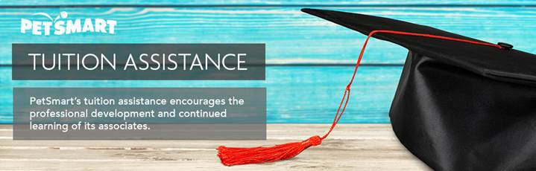
Application for PetSmart’s Tuition Assistance Program

Purpose
PetSmart is proud to offer tuition assistance for both full time and part time active associates that have worked an average of 20 hours a week or more in the preceding 12 months. Please refer to PetSmart’s Tuition Assistance Program Policy or search Tuition on Fetch prior to submitting your application.

Easy Steps for Submitting Your Application
Submit application 30 days before to 30 days after start date of class. You will receive an acceptance email with next steps. Once classes are complete, submit grades, receipts and any applicable documentation 30 days after completion of class. You will receive a confirmation email of receipt of grades and notification of funds that will be reimbursed.

Personal Information
First Name: Middle Name: Last Name:
Hire Date: Assoc. ID #:
Current Home Address:
City: State/Province: Zip/Postal Code:
Work Location: Store # DC # Phoenix Home Office Canada Office
Mail Check to: Home Workplace Direct Deposit
Please Note: If you elect direct deposit you must complete and sign a direct deposit form for each application submitted. This form can be found on the Tuition Assistance Fetch home page.
Department: | Current Position Title:
Daytime Phone: | Preferred Email Address:
Course/School Information
Course 1 | Start Date: | # of Credits: |  | Title:
Course 2 | Start Date: | # of Credits: |  | Title:
Course 3 | Start Date: | # of Credits: |  | Title:
Course 4 | Start Date: | # of Credits: |  | Title:
School/Institution Attending:
What Degree Level Are You Pursuing: Undergraduate Degree Graduate Degree Neither
Program of Study:
Major: |  |  | Minor:

Receipts must be submitted within 30 days of course completion.
Tuition (Course 1) $
Tuition (Course 2) $
Tuition (Course 3) $
Tuition (Course 4) $
Registration $
Books $
Total Cost $

Additional Information Required
Please submit the following information with your application (additional information may be requested if necessary).
Degree program (if not previously provided)
Book receipts (if applicable)
Tuition receipts

Associate Policy Acknowledgement
I have read the Petsmart Tuition Reimbursement Policy in full and I agree that upon termination of my employment, and according to PetSmart’s Tuition Assistance Program Policy, I agree to the Repayment Requirements.
Associate’s Signature: Date:
Associate Name in Print:

Immediate Manager/Supervisor Approval
By signing this form, I acknowledge that I have discussed career development and continuing education goals with my associate and I have verified eligibility requirements based on PetSmart’s Tuition Assistance Program Policy.
Manager/Supervisor Signature: Date:
Manager’s Name and Title in Print:

Reimbursement Procedures
Within 30 days of course completion you must provide your final grade, or equivalent official documentation, receipts for reimbursable expenses and any additional applicable documentation to PetSmart via mail, fax or email:
Mail | PetSmart, Inc.  Attention: HR Shared Services – Tuition Assistance  19601 N. 27th Avenue  Phoenix, AZ 85027
Fax | 1-800-738-9917
Email | TuitionAssistance@petsmart.com

Please allow four to six weeks for processing of reimbursements.

